Lost words:

Read and complete the text of each person’ use the words lost outside the box:

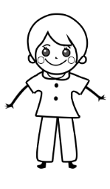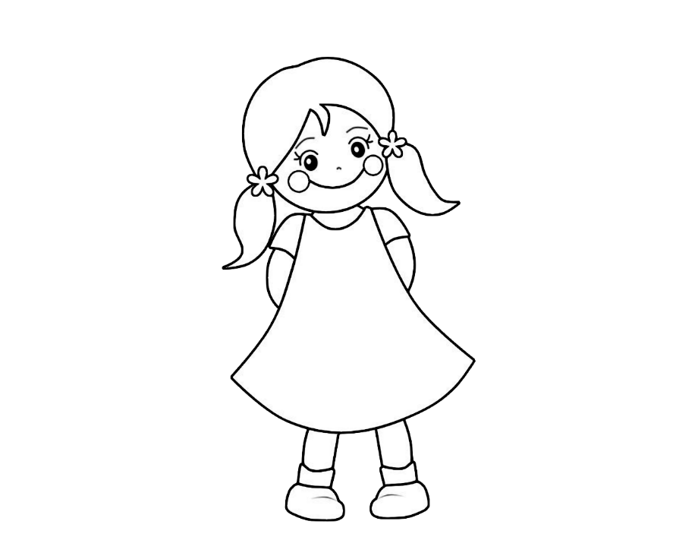

أَنااِسْمِي............. أَنَا عُمْرِي تِسْعُ ............ أَنَا ........ بَرِيطَانْيَا أَنامُجْتَهِدُ و...........

أَنا..........مَرْوة. أَنَا ..............تِسْعُ سنَوَات. أَنَا مِنْ................... أَنا جَمِيلَةٌ و...........

Which letters when joined makes the word:

ذَكِيَةٌ

مُجْتَهِدَةٌ

Join the English to Arabic:

Clever

Beautiful

Hardworking

strong

مُجْتَهِدَةٌ

ذَكِية

قَوِيَة

جَمِيلَة

Change the following words to feminine:

|  |  |
| --- | --- |
| **مُؤَنَث** | **مَذَكَر** |
|  | جَمِيلَ  قَوِيٌ  مُجْتَهِدَ  ذَكِـِيٌ  طَوِيلٌ  كَبِير |

Salma wrote these sentences she used wrong words can you find it and correct it please and give her a mark:

The wrong words or where is missing a letter are underlined

عُمْرِي سَلْمَى

..............................................................................

اسْمِي عَشْرُ سَنَوات

..............................................................................

أَنَا ذَكِـي

..............................................................................

Circle the correct spelling:

|  |  |  |  |
| --- | --- | --- | --- |
| beautiful | جاميل | جمل | جميل |
| clever | ذكـي | ذقـي | زكـي |
| Tall/long | طويل | طاويل | تويل |
| Hard working | مجتهدة | مجتحدة | مجتهدة |
| Funny | مضهكة | مضحكة | مذحكة |
| Strong | قوي | قو | كوي |
| small | صغير | سغير | صقير |
| short | قسير | كصير | قصير |

Word search:

Find the following words in the grid below.

طويلة ذكّـي قصير قوّي مضحك جميلة مجتهدة

|  |  |  |  |  |  |  |  |
| --- | --- | --- | --- | --- | --- | --- | --- |
| ذ | ط | ة | د | ه | ت | ج | م |
| ق | ف |  | ط | م | ح | ض | ن |
| ي | ي | ي | و | ق | ح | ك | ت |
| ج | ل | ف | ي | ك | ذ | س | ه |
| م | ـة | ر | ل | و | ك | ي | د |
| ي | ـة | ق | ح | ذ | م | ر | ة |
| ل | ص | ر | ي | ص | ق | و | م |
| ـة | ع | ث | م | ش | ي | ك | ز |

Use the information below for Seloua to be able to introduce herself:



جَمِيلَة

المَغْرِب

10

سَلْوى

أَنَا.....................................................................................

.....................................................................................

.....................................................................................

.....................................................................................

Translate the following sentences:

I am clever

………………………………………………………………………..…………

I am hard working

……………………………………………………………………..……………

I am funny

……………………………………………………………………………………

I am beautiful

…………………………………………………………………………………….

I am old

…………………………………………………………………………………….

I am strong

…………………………………………………………………………………….

I am tall

…………………………………………………………………………………….

Answer the following question using the word in bracket:

مِنْ أَيْنَ أَنْتَ؟

أَنَا مِنْ المَغْرِب (المغْرِب)

مِنْ أَيْنَ أَنْتَ؟

....................................................................( بَاكِسْتَان)

مَا اِسْمُكَ؟

..................................................................( مُصْطَفَى)

كَمْ عُمْرُكَ؟

...................................................................(9)

كَيْفَ حَالُكَ؟

................................................................( بِخَيْر)

Read and understand:

أأَنَا اسْمِي فَاطِمَة, أَنَا عُمْرِي سَبْعُ سَنَوات, أَنَا مِنْ الجَزَائِر.

أَنا أَسْكُنُ فِي لُنْدُنِ. أَنَا ذَكِّية و قَوِّيَة.

أأَنَا اسْمِي يُوسَف, أَنَا عُمْرِي ثَمَانُ سَنَوات, أَنَا مِنْ المَغْرِب.

أَنا أَسْكُنُ فِي لُنْدُنِ. أَنَا ذَكِّـي و قَوِّيٌ.

Name:

Year:3

I can work independently.

My teacher gave me all the necessary vocabulary.

Date:



أَنَا ذَكِيٌ

أَنَا ذَكِيَة

Mum, dad don’t help me please

Please use the previous vocabulary to complete the task:

Comments:…………………………………………………………………………………………………………………………………………………………………………………………………………………………………………………………………………………………………………………………………………………………………………………………………………………………………………………………………………….

Thankyou

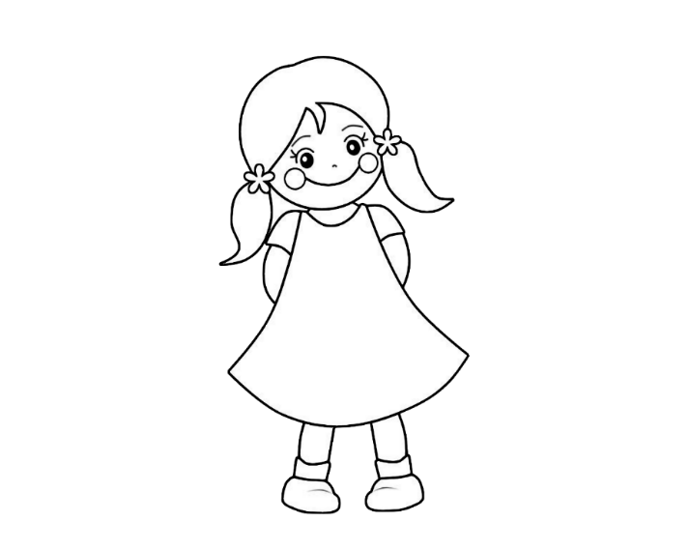Which texts belong to Ahmed and which texts belong to Marwa:

أأَنَا قَوِّية و ذَكِّية, أَنَا أَسْكُنُ فِي لُنْدُن

أأَنَا طَوِيلٌ و مُجْتَهِدٌ, أَنَا أَسْكُنُ فِي لُنْدُن

أأَنَا عُمْرِي عَشْرُ سَنَوَات

Some sentences belong to Sami and some not, can you draw an arrow to the one which belong to him:



Match the English to Arabic:

My name is Mouna

she is strong

He is strong

I live in London

I am beautiful

I am 10 years old

أَسْكُنُ فِي لَنْدَنِ

هَوَ قَوِّيٌ

هِيَقَوِّيَةٌ

اِسْمِي مُنَى

أَناعُمْرِي عَشْرُ سَنَوِات

أَنا جَمِيلة

Tick the correct answer:

**He : هُوَ**

**She : هِيَ**

هُوَ

هِيَ

هَوَ

هِيَ

Read and understand:

Underline the adjectives

أأَنَا اسْمِي فَاطِمَة, أَنَا عُمْرِي سَبْعُ سَنَوات, أَنَا مِنْ الجَزَائِر.

أَنا أَسْكُنُ فِي لُنْدُن. أَنَا ذَكِيَّة و قَوِيَة.

أَبِي مُجْتَهِدٌ و أُمِّي جَمِيلة. أَخِي ذَكِّيٌ و أُخْتِي مُضْحِكَةٌ.

Write the adjectives in the right column:

|  |  |
| --- | --- |
| مُؤَنَث | مُذَكَر |
|  |  |
|  |  |
|  |  |
|  |  |
|  |  |
|  |  |
|  |  |

Which letters when joined makes the word:

طَوِيلَة

قَوِيَة

Practice writing:

أَنَا جَمِيلَة

أَنَا قَوِية

أَنَا مُجْتُهَدَة

أَنَا طَوِيلَة

هُو مُجْتَهِدٌ

هِيَ صَغِير

أَبِي قَوِي

Translate the following text into Arabic:

My name is Ahmed, I am 7 years old, I am British. I live in London. I am tall and I am funny and I am clever.



……………………………………………………………………………………………………………………………………

…………………………………………………………………………………………………………………………………..

………………………………………………………………………………………………………………………………….

………………………………………………………………………………………………………………………………

………………………………………………………………………………………………………………………………….

Lost words read the text and and add the missing words:

أأَنَا اسْمِي .........., أَنَا عُمْرِي ........... سَنَوات, أَنَا مِنْ مِصْر.

أَنا أَسْكُنُ فِي ............ . أَنَا ذَكِيٌّ و قَوِّيٌ.

أَبِي .......... و أُمِّي جَمِيلة. أَخِي ذَكِّيٌ و أُخْتِي مُضْحِكَةٌ.

Read and understand:

Answer the following questions according to the text:

أَنَا اِسْمِي مَرْيَم ذَكِيَّة و قَوِيَة.

أَبِي مُجْتَهِدٌ و أُمِّي جَمِيلة. أَخِي ذَكِّيٌ و أُخْتِي مُضْحِكَةٌ.

Meriam is:

hardworking

Funny

clever

The Dad is:

clever

strong

hardworking

The mum is:

hardworking

Beautiful

funny

The sister:

hardworking

funny

hardworking

The brother:

clever

Word search:

Hard workingFunny (F)

Clever beautiful

SmallTall (F)

Short

Strong

|  |  |  |  |  |  |  |  |
| --- | --- | --- | --- | --- | --- | --- | --- |
| ر | ي | ص | ق | ة | ق | غ | ق |
| ظ | ز | غ | ت | ض | ش | و | ل |
| ر | ق | ي | ت | ذ | ي | ي | ؤ |
| ط |  | ر | ـة | كـ | ح | ض | م |
| و | ؤ | ق | س | ي | ف | ل | ج |
| ي | ذ | د | ر | ز | ة | ى | ت |
| ل | ـة | ل | ي | م | ج | خ | ه |
| ـة | ص | ث | ت | ف | ب | ح | د |

Join the letters to make words:

م+ض+ح+ك+ــة=

ق+و+ي=

ج+م+ي+ل+ـة=

ط+و+ي+ل+ـة=

ق+ص+ي+ر=

ذ+ك+ي=

ص+غ+ي+ر=

ق+و+ي+ـة=

Unscramble the word:

Funny (F)

.................

ض م ك ح ـة

Small (M)

.................

ص ي غ ر

Clever (M)

.................

ي ك ذ

Circle the naughty letters in the following words:

|  |  |  |
| --- | --- | --- |
| مِحْفَظَة | مِسْطَرَة | قَلَمٌ |
| مُجْتَهِدَةٌ | ذَكِّـيٌ | كُرّاسٌ |
| صَغِيرَةٌ | جَمِيلَةٌ | قَوِّيٌ |
| مِبْـرَاة | دُودَة | قَصِيرَة |

Correct the mistake:

Ahmed does not know his naughty letters, he joined some letters which he is not supposed to join it:

كُرّاسٌ=

ذَكِـي=

مُجْتَهِدَةٌ=